How create vuejs in vscode

1. install NodeJs
2. Open VS Code and Open terminal
3. npm install -g @vue/cli
4. vue create name example vue create my-app
5. cd name example cd my-app



when vue create my-app will be :

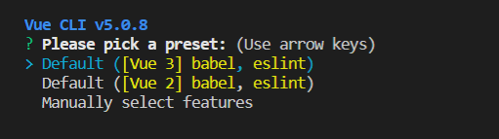

1. Use Vue version 3 babel and eslint
2. Use Vue version 2 babel and eslint
3. Myself setting vueJS

I will create type myself setting

when I select myself setting will show this image :

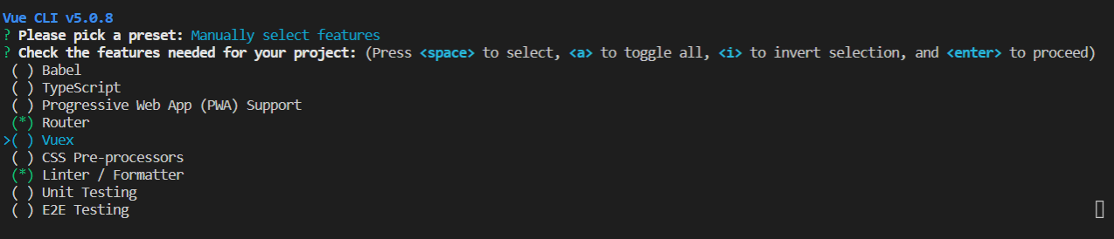

\*\*\* if you don’t want select to press space bar

I will select : Router and Linter / Formatter

Babel is compiled tools convert from ES6 to ES5

TypeScript is languages Compile from computer languages to JavaScript and TypeScript to be make code you have quality

Router is managed webpage between page to page

Vuex is help manage redundant code and manage the code more websitesystem

CSS Pre-processors is CSS languages to oriented programing

Linter / Formatter is help manage code look organized and beautiful code

Select Version VueJS I will select Version 2.x

